Pemberley Sculpture in the Vines – April 2026

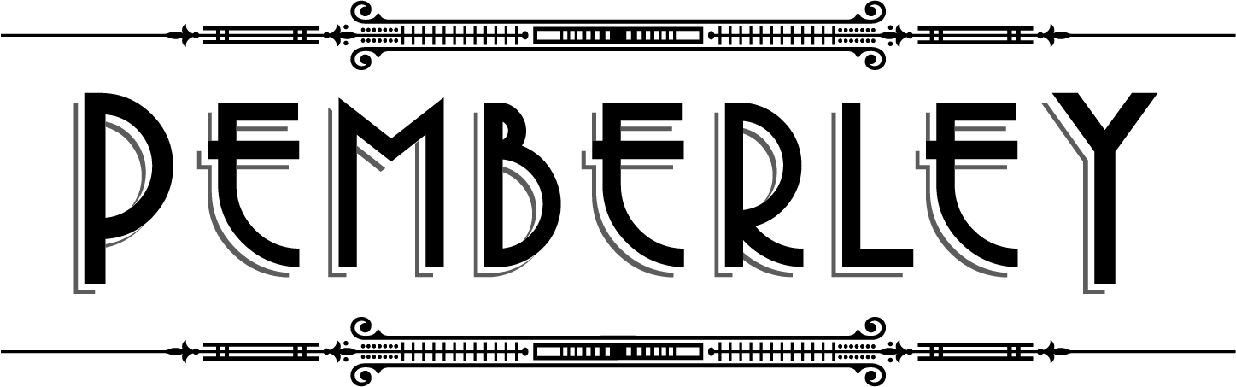

- Shire of Manjimup & Pemberton Arts Group - Acquisitive up to $15,000
  - Recipient: Wayne Smith – Joining Forces

- RC & JM Baker - Open Acquisitive
  - Recipient: Lesley Barrett – Wood In Awe of Its Own Beauty

- Mona & Torsten Ketelsen Award - $1000
  - Recipient: Greg James – Gaia

- Rygold Nominees Award - $1000
  - Recipient: Wayne Smith – Lilies

- OPS Screening & Crushing Equipment Pty Ltd - $500
  - Recipient: Michael Brocksopp – 2000 Poppies

- Johnson Insurance Brokers - $500
  - Recipient: Kim Perrier - Surge

- Farmlink Rural Manjimup - $500
  - Recipient: Sara De Petris – Treasure Chest

- Pemberton Discovery Tours - $330 voucher
  - Recipient: Mark Grey Smith – Hash Tag

- Southern Forests Chocolate Company - $200
  - Recipient: Paul Fontanini – Recycling Metamorphosis



